Introduction & Setup

# Introduction

JobMine EZSearch is a productivity app that facilitates searching for jobs from JobMine, Waterloo’s co-op portal.

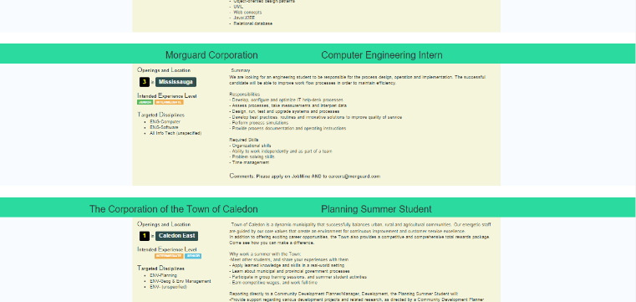Imagine you were a .NET developer who wanted to apply to all jobs that require .NET knowledge. How would you go about finding all .NET jobs? Many job titles do not contain the words “.NET” and clicking on every job to read their summaries is not ideal (learned this the hard way, it was not pretty).

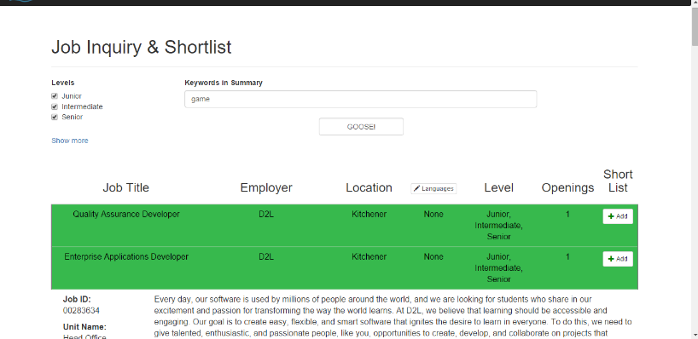JobMine EZSearch solves this problem by searching for keywords for job summaries. Simply type in “.NET” in the keywords search bar and all jobs with .NET in their summaries appear. JobMine EZSearch also integrates with JobMine’s “Add to/Remove from shortlist” feature so you can shortlist desirable jobs by clicking on the “Add” or “Remove” button next to them.

# Core Features

* **Refined Search Mechanism:** In addition to almost all of JobMine’s search filters, JobMine EZSearch can also search by keywords, prioritized languages, or you can write your own SQL queries.
* **Integrates with Short List:** Add or remove jobs from your shortlist with a single click. A text file is also created showing all jobs you have added to shortlist.
* **Download Formats:** Download all jobs in four file formats: Word, HTML, CSV, and TXT
* **Open to Extension:** Stores jobs from JobMine to a local database so that you can use the data to build your own applications.
* **Fast and Functional:** Once JobMine EZSearch has finished setting up the local database with all jobs, you can instantaneously* search through 3000+ jobs and view jobs without waiting for page loads
* **GUI:** A rich responsive display powered by Bootstrap.
* **GNU GPL3 License:** Play with the source code however you wish.

# Setup for Windows

Yes I know, it looks like there are a quadrillion steps but don’t worry, they’re easier than they seem and generally takes less than 15 minutes (including waiting for file to install).

**Step 1:** Since JobMine EZSearch is a Python project, let’s download Python 3.5.2 from <https://www.python.org/downloads/>. On the first wizard path check the “Add Python 3.5 to PATH” checkbox and install Python.

**Step 2:** After Python 3.5.2 has been installed, download the PyCharm Community IDE from <https://www.jetbrains.com/pycharm/download/#section=windows> .

**Step 3:** Open PyCharm and click on “Check out from Version Control” and select “Git”. In the new popup, enter <https://github.com/NanoBreeze/JobMine-EZSearch.git> into Git Repository URL.

**Step 4:** This part is a bit tricky. Open your browser to <http://www.lfd.uci.edu/~gohlke/pythonlibs/#lxml> and download the file *lxml-3.6.4-cp35-cp35m-win32.whl*. This file is needed to create Word documents of jobs.

**Step 5:** Open your Command Prompt as Administrator (if you’re on an administrator account, it automatically opens in Administrator mode) and navigate to the directory that contains *lxml-3.6.4-cp35-cp35m-win32.whl* is installed. Type cd.. to go up a folder and cd <folder name> to go to a child folder.

**Step 6:** Type pip install lxml-3.6.4-cp35-cp35m-win32.whl

**Step 7:** Run *preSetup.py* from Pycharm’s Project window (on the left side of the screen) and remember to enter your username and password in the run console. These are stored in a local database and aren’t being snooped by mastermind. Your entered credentials stay only on your drive

**Step 8:** After a job is downloaded, its summary will appear in the Run panel. It normally takes 5-15 mins to download all the jobs. After the jobs are downloaded double click on Main.py (or use python Main.py from the Command Prompt). Then run Main.py (click on Run->Run…->Main). If Main.py threw an “Error running Main:” exception, you can set the Interpreter by Run->Edit Configurations… and select Python 3.5.2.

**Step 9:** Click the blue link that appears in the Run window (eg, <http://127.0.0.1:5000>). This opens JobMine EZSearch. Any time you want to open JobMine EZSearch, run Main.py. You can navigate to “Job Inquiry & Shortlist” to search and shortlist jobs.

Hope this helps! If you run into any troubles, let me know.